

RIGHTLINE™

IVLS INTEGRATION PROJECT
QTP AUTOMATION FRAMEWORK AND GUIDELINES

Client Name | IDEXX
Project Name | IVLS INTEGRATION

TEST AUTOMATION FRAMEWORK USER GUIDE

Ver. No. | Date | Prepared/ Changed By | Approved By | Description
1.0 | Aug 08, 2014 | Ramesh Babu Allipilli |  | Baseline

TABLE OF CONTENTS
1. Purpose 1
1.1 Definition 1
1.2 Features of a Framework 1
2 About Test Complete Tool 2
2.1 Test Execute 2
2.2 Distributed Testing 2
3 System requirements 3
3.1 Hardware Specifications 3
3.2 Software Specifications 3
3.3 Remote Desktop Access 4
4 Configuration Setup 5
4.1 Network Connection Setup 5
4.2 IVLS Network Connection setting 5
4.3 Interlink Configuration Settings in Corner Stone 7
4.4 DSN Connection Setup in Automation Server Machine 8
4.4.1 Check OBDC SYBASE DRIVER “ SQL Anywhere 16” 8
4.4.2 How to install “SQL Anywhere 16” driver in Automation Server 8
4.4.3 Create DSN Connection String 8
5 Automation Architecture Design 9
6 Automation Framework Folder Structure 9
6.1.1 Configuration Setup 10
6.1.2 Test Suite 11
6.1.3 Test Scenario 11
6.1.4 Test Data 12
6.1.5 Functional Library 14
6.1.6 Test Controller 14
7 Test Script Execution 15
8 Test Report 16

Purpose
Smart Bear Test Complete tool, is an advanced automated testing software for building functional and regression test suites. It captures, verifies and replays user interactions automatically and helps tester quickly identify and report application effects, while providing advanced functionality for tester collaboration.
This document focuses on defining a TestComplete distributed automation hybrid framework, including a set of guidelines used in designing various components of framework, like handling host machines for simultaneous remote executions, handling test data across remote machines, Corner Stone data base functions etc. This framework also enforces a set of standards for implementation.

Definition
A framework is a basic conceptual structure used to solve or address complex issues. A structure consists of all the building blocks for developing an application. Test Automation framework, is a set of assumptions, concepts, and practices that provide support for Automated Software Testing.
Framework can be defined as a road map or a test plan for automated testing that drives entire process or project in an organized way to execute the developed test scripts. It is basically a set of standards or guidelines to be followed, irrespective of the project details. Every company defines its own guidelines based on the past experiences and lessons learnt from the earlier projects.

Features of a Framework
There are some basic features that a framework is expected to have as mentioned below:
- Simultaneous distributed testing across different applications ( IVLS , Corner Stone and Simulators)
- Setting up HOST Connections automatically based on HOST details specified on Configuration XML file.
- Handling Global Test Data across remote machines
- Connecting to Corner Stone Date for validations
- Centralized end-to-end test repost.

About Test Complete Tool
Test Complete provides an open test platform for easily creating, maintaining, and executing automated tests for desktop, Web, mobile, and client-server software applications.

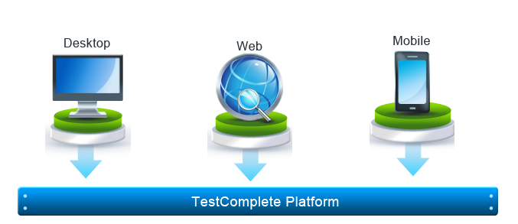
It is primarily used for functional regression test automation. The design philosophy behind Test Complete is to never inhibit or restrict a QA team. One illustration of this is that with Test Complete you never have to use a proprietary scripting language for test case automation. Test Complete is the only tool of its kind with built-in support for multiple scripting languages: VBScript, JScript, C++Script, C# Script and Delphi Script.

Test Execute
Test Execute is a lightweight test runner for Test Complete tests. It allows you to execute Test Complete tests without having to install Test Complete on a computer. Test Execute can be used on remote computers, virtual machines and CLOUD COMPUTERS participating in distributed testing, or on any test computer where you need only to run tests.

Distributed Testing
Distributed tests are applied for testing distributed applications, that is, the applications that are working with multiple clients simultaneously: client/server solutions, web applications and so on. Testing a distributed application involves testing its client and server parts. You can always test them separately, but distributed testing gives you a way to test them all together

System requirements

Hardware Specifications

APPLICATION / MACHINE
IDEXX VET LAB SSTATION MACHINE | AMD Athlo ™ II X2B6  Processor 3.20 GHz RAM 3.24 GB  Microsoft Windows XP Professional Version 2002  Service Pack 2
CORNER STONE MACHINE | AMD Athlo ™ II X2B26  Processor 3.20 GHz RAM 3.24 GB  Microsoft Windows XP Professional Version 2002  Service Pack 2
SIMULATOR MACHINE | MD Athlo ™ II X2B6  Processor 3.20 GHz RAM 1 GB  Microsoft Windows XP Professional Version 2002  Service Pack 2
AUTOMATION SERVER | AMD Athlo ™ Processor 16408 or higher  2.71 GHz RAM 1 GB  Microsoft Windows XP Professional Version 2002  Service Pack 2

Software Specifications

APPLICATION / MACHINE
IDEXX VET LAB SSTATION MACHINE | Test Execute S/w installed  IVLS Application Installed
CORNER STONE MACHINE | Corner Stone Application Installed
SIMULATOR MACHINE | Test Execute s/w Installed  Simulator Application Installed  Share Simulator Application folder with read/write access to Automation Server.  Copy Simulator Application Folder under c:
AUTOMATION SERVER | Test Complete S/w Installed  Framework Folder Structure shared under c:\  Framework folder is shared with read/write access IVLS Corner Stone and Simulator machines.

Remote Desktop Access
Configure remote desktop access permissions for Automation Server Admin user to access IVLS Machine, Corner Stone Machine and the Simulator Machine.

To provide remote access permissions logon to respective machines (IVLS , Corner Stone and Simulator)

Step 1: Right click on MY Computer folder on desktop of respective machines
Step 2: Navigate to REMOTE tab on System properties window.
Step 3: Check “Allow Remote Assistance invitations to be sent from this computers” checkbox
Step 4: Check “Allow user to connect remotely to the computer” check box

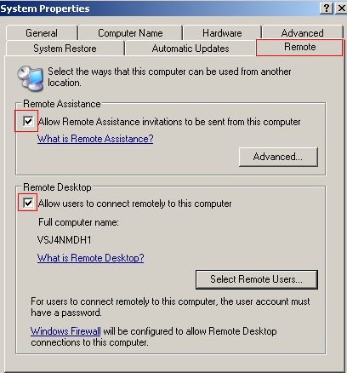

Configuration Setup

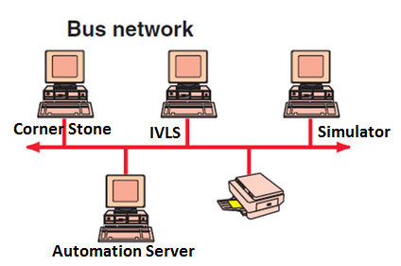 | 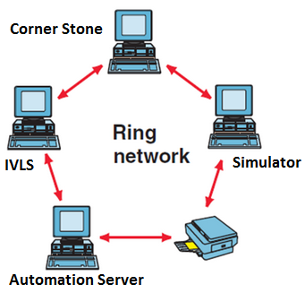

Network Connection Setup

Use either of the above network approach to connect IVLS , Corner Stone Simulator and Automation Server machines.

IVLS Network Connection setting

Step 1: Click on Settings button on IVLS Home Screen
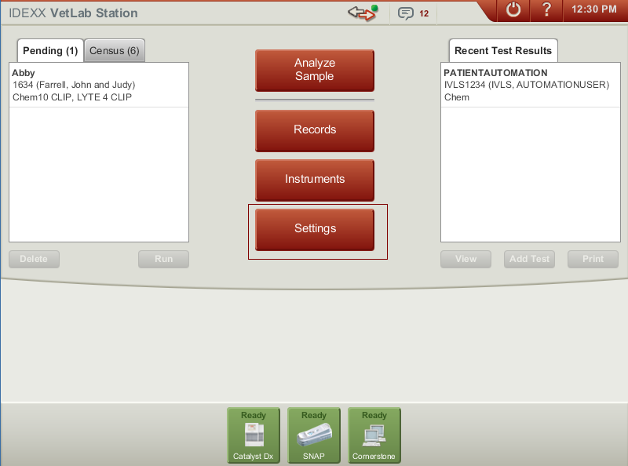

Step 2: Click on Practice Management tab

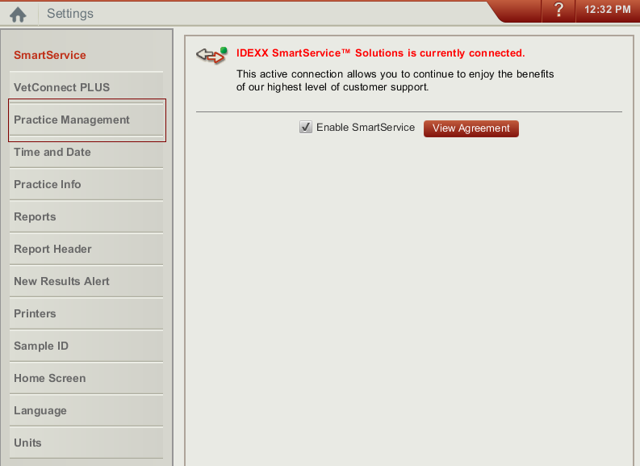

Step 3: Select Network Connection option and click Configure button

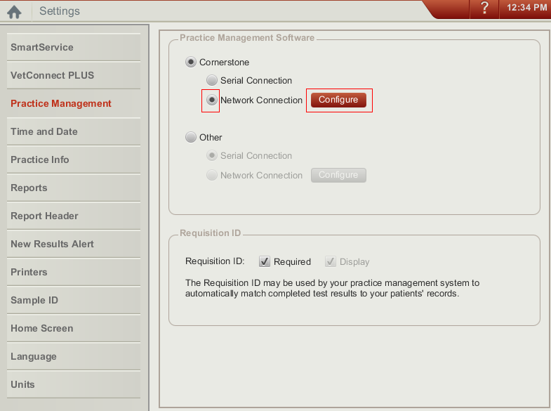

Step 4: Check Direct Connect Radio option

Step 5: Enter Corner Stone Machine IP Address and Click OK button

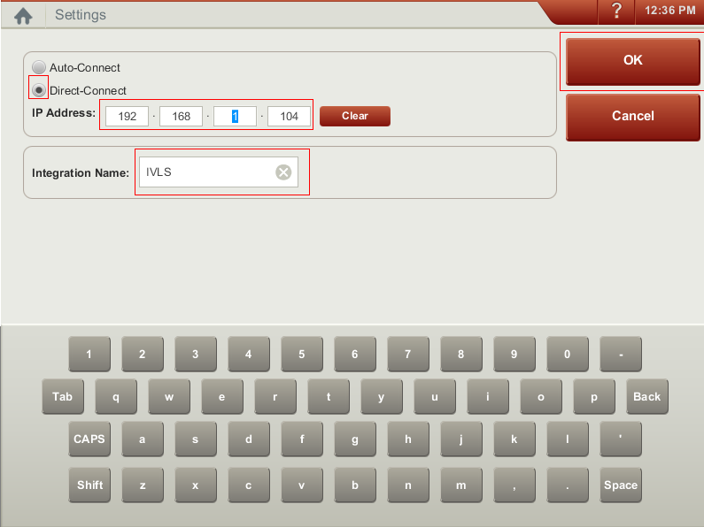

Interlink Configuration Settings in Corner Stone

Step 1: Login As Administrator

Step 2: Navigate to Set Lab Workstation under Activities menu

Step 3: Check Interlink Checkbox as show in below screenshot
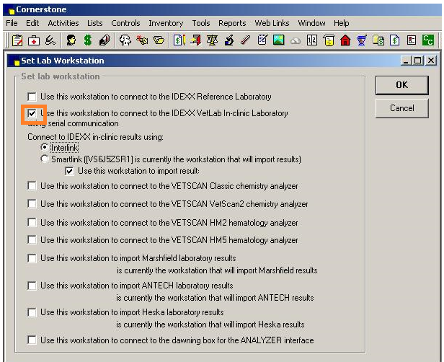

DSN Connection Setup in Automation Server Machine

Check OBDC SYBASE DRIVER “ SQL Anywhere 16”

Step 1: Open ODBC Database Administrator window from Control Panel >> Administration Tools >> Data Source (ODBC)

Step 2: Navigate to Driver tab and check if “SQL Anywhere 16” is available in the list

Step 3: If “SQL Anywhere 16” click ok. Now we are good to setup DSN Connection in the automation server.

How to install “SQL Anywhere 16” driver in Automation Server

Step 1: Copy the below attached zip file to Automation Server local drive.

Step 2: Unzip the folder

Step 3: Copy all the DLL’s and files under the folder to WINDOWS\System 32 folder in Automation Server

Step 4: Now SQL Anywhere 16 driver is available under Control Panel >> Administration Tools >> Data Source (ODBC) >> Driver

Create DSN Connection String

Step 1: Open ODBC Database Administrator window from Control Panel >> Administration Tools >> Data Source (ODBC)

Step 2: Click on Add button under User DSN tab and select “SQL Anywhere 16” Driver from the list displayed click Finish button

Step 3: Enter User ID (csdbo) , Password ( csdbo) , Action “ Connect to a running database on another computer”

Step 4: Enter HOST as Corner Stone Machine Name and PORT is not applicable

Step 5: Enter Server Name and Database name as “cstone”
Step 6: On ODBC tab click on TEST CONNECTION” button, to ensure ODBC connection is success.

Automation Architecture Design
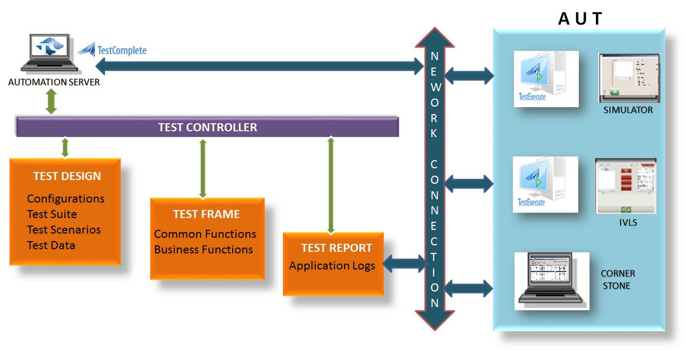

Automation Framework Folder Structure
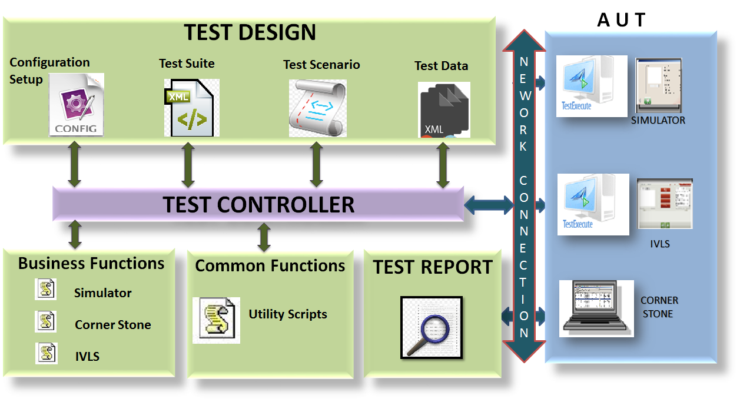

Configuration Setup
The Configuration setup XML file contains Project configuration settings and Host configuration settings details.

Project Configuration settings contains base framework folder path, project name, Simulator application path details , IVLS Application details , Corner Stone Application details Synchronization wait property details…etc.

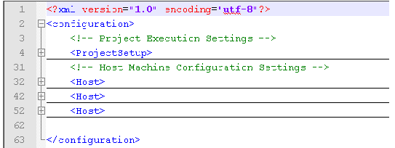

Host Configuration settings contains Host machine name, user name …etc. ,

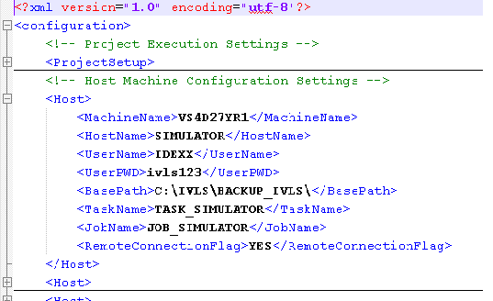

File Path: - ..\IVLS_INTEGRATION_AUTOMATION\IVLS_Integration\TESTDESIGN\TESTENVIRONMENT\Configuration.xml

Test Suite
When user want to create new test scenario, an entry has to me made in Test suite file by providing the below details.

- Scenario ID
- Scenario Name
- Data Iteration
- Iteration Count
- Scenario Execution Flag
- Test Data Name

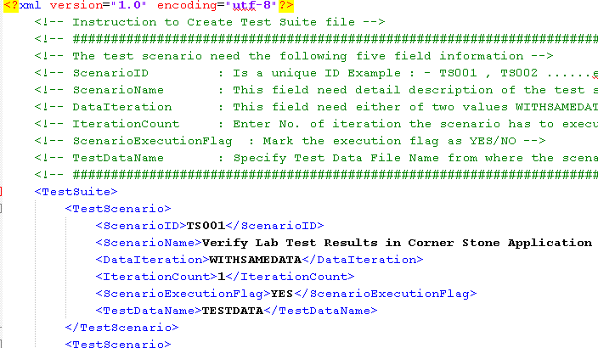

File Path: -..\IVLS_INTEGRATION_AUTOMATION\IVLS_Integration\TESTDESIGN\TESTSUITE\TestSuite.xml

Test Scenario

The user has to provide the following details to create end to end test scenario flow mapping to respective Scenario Id specified in Test Suite XML file.

- Test Scenario ID
- Test Step ID
- Step Description
- Perform Action / Business Function Name
- Input Data
- Step Execution Flag
- Application Name
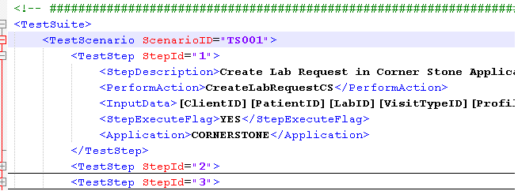

File Path: -..\IVLS_INTEGRATION_AUTOMATION\IVLS_Integration\TESTDESIGN\TESTSUITE \TestScenario.xml

Test Data

The test data passed to each test scenario is provided in test data XML file.

We have to map Scenario ID, Business Iteration, Function Name and Input Parameters.

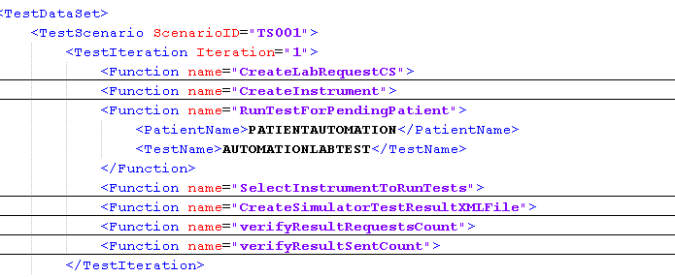

File Path: ..\IVLS_INTEGRATION_AUTOMATION\IVLS_Integration\TESTDESIGN\TESTDATA\TestData.xml

SIMULATOR Test Data templates contains instrument test result
File Path: :- ..\IVLS_INTEGRATION_AUTOMATION\IVLS_Integration\TESTDESIGN\TESTDATA\SIMULATOR\catalyst.xml

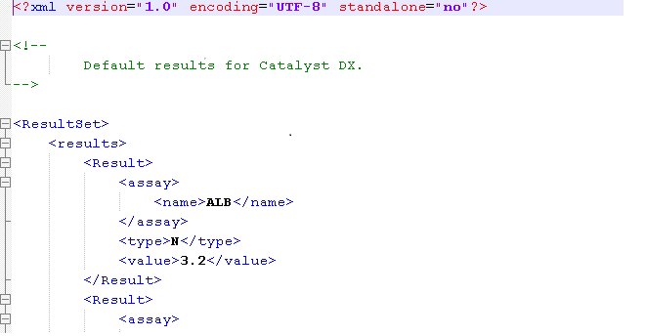

Functional Library

There are two main folders in Functional library
- Common Functions
- Business Functions

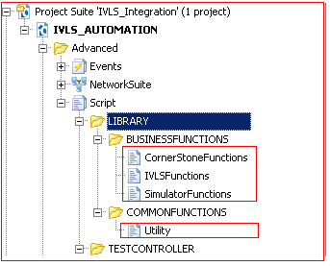

Common functions contains methods to create Configuration setup by reading data from configuration file , reading data from test suite file, reporting methods…etc.

Business function folder contains three sections to add application specific business in respective Application folder.

Test Controller

The test controller is a driver script which reads test suite details from the test suite file and executes the respective test scenarios marked for execution. The driver script even has control at test step level either to execute or skip test steps based on information specified in test scenario file. The test steps are the business functions associated with test data configured in Test data file. The driver script reads the test data from test data XML respective to associated business functions. The driver Script executes the business function on respective application configured on the Remote machine.

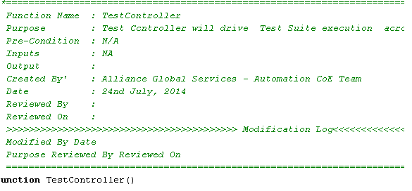

Test Script Execution

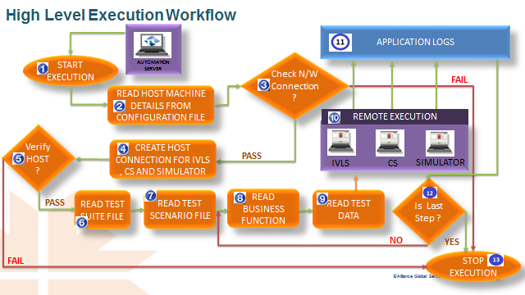

Test Report

The report captures details at low level information as network connection status , Host connection status , user actions on remote applications , Test scenario status , business function status … etc.
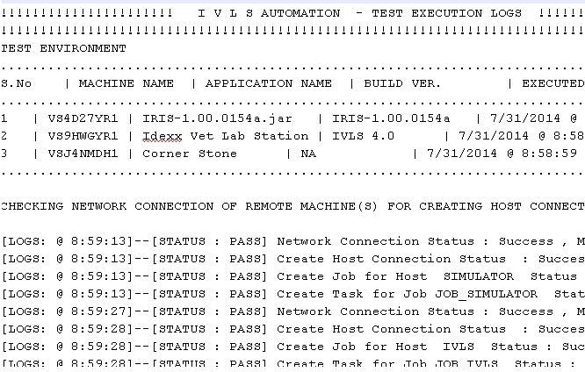

File Path: -..\IVLS_INTEGRATION_AUTOMATION\IVLS_Integration\TESTRESULT\LOGS

